Echoes of Expression: Coordinates

AR Art Exhibition Map Layout

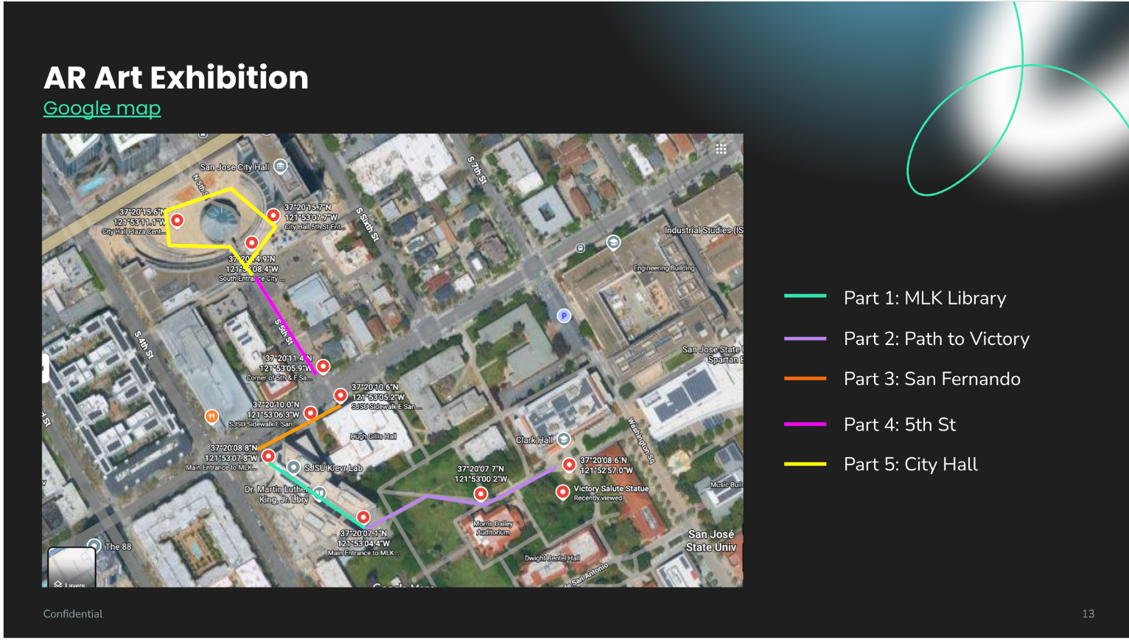

Who We Are: Coordinates
Path to Victory
- 37°20'08.6"N 121°52'57.0"W
  - Wwa_pt_01.glb

Tower Hall Lawn Area
- 37°20'07.7"N 121°53'00.2"W
  - wwa_pt_02.glb

Echoes of Expression: Coordinates
- Main Entrance to MLK Library - SJSU Side
37°20'07.1"N 121°53'04.4"W
Immersion_echoes_of_exp_official_map_pt_01.glb

- Main Entrance to MLK Library - City Side
37°20'08.8"N 121°53'07.8"W
immersion_eoe_monster.glb

- SJSU Sidewalk E San Fernando - Walkway to Library
37°20'10.0"N 121°53'06.3"W
Immersion_eoe_commotion_pt_01.glb
immersion_eoe_commotion_pt_02.glb
immersion_eoe_commotion_pt_03.glb

- SJSU Sidewalk E San Fernando - Film & Theatre
37°20'10.6"N 121°53'05.2"W
Immersion_eoe_commotion_pt_04.glb
Immersion_eoe_commotion_pt_05.glb
Immersion_eoe_commotion_pt_06.glb

- Corner of 5th & E San Fernando
37°20'11.4"N 121°53'05.9"W
immersion_eoe_TV_animation.glb

- S 5th St
37.336849, -121.885216
text_as_image.glb

- City Hall 5th St Entrance & Courtyard Seating
37°20'15.7"N 121°53'07.7"W
Immersion_eoe_abstract_bird_animation.glb

- South Entrance City Hall
37°20'14.9"N 121°53'08.4"W
Immersion_eoe_spongemeboi_animation.glb

- City Hall Plaza Center
37°20'15.6"N 121°53'11.1"W
Engine AR Promo.mp4

